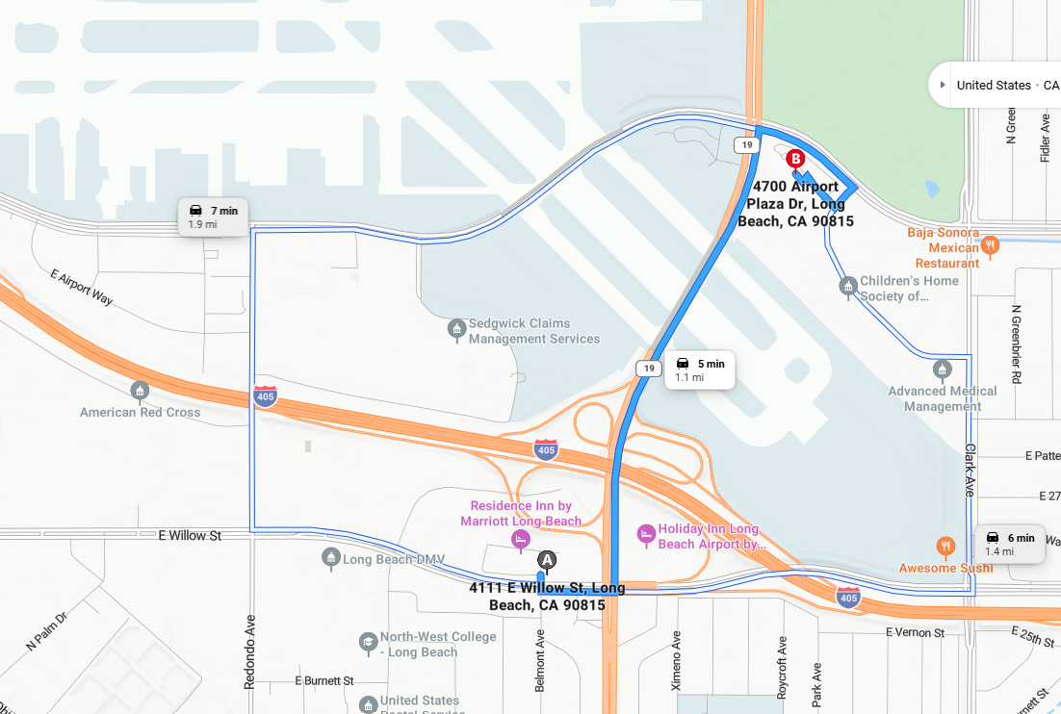
Directions via CA-19
4111 E Willow St, Long Beach, CA 90815
Leave
about 0.1 mi, less than 1 min
Turn left onto E Willow St
0.1 mi, about 1 min
Turn left onto N Lakewood Blvd/CA-19 toward San Diego Fwy N
0.7 mi, about 2 min
Turn right onto E Spring St
about 0.2 mi, less than 1 min
Turn right onto Airport Plaza Dr
about 0.1 mi, less than 1 min
Turn right
about 0.1 mi, less than 1 min
Turn left
about 0.1 mi, less than 1 min
Turn right
about 0.1 mi, less than 1 min
You have arrived
B
4700 Airport Plaza Dr, Long Beach, CA 90815

