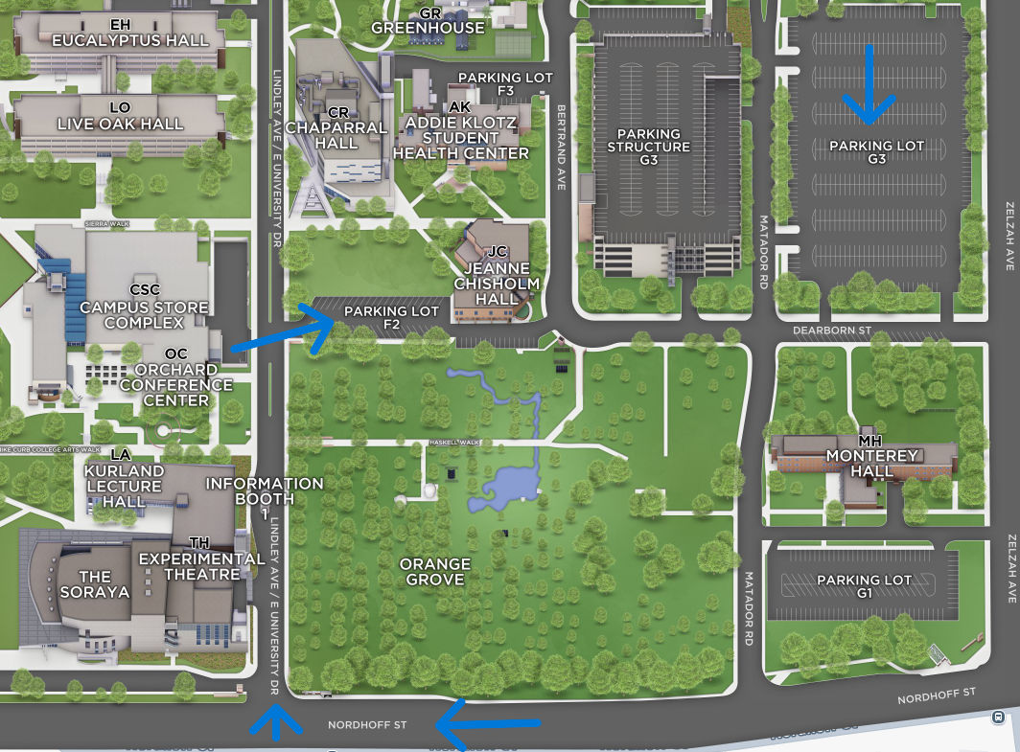

Enter from Nordhoff and Lindley, you’ll pass a Information booth, Orchard conference will be on your left and parking will be on your right Parking Lot 2, parking is also available in Parking Lot G3